Where are they now?
Year 13 student destinations

2016

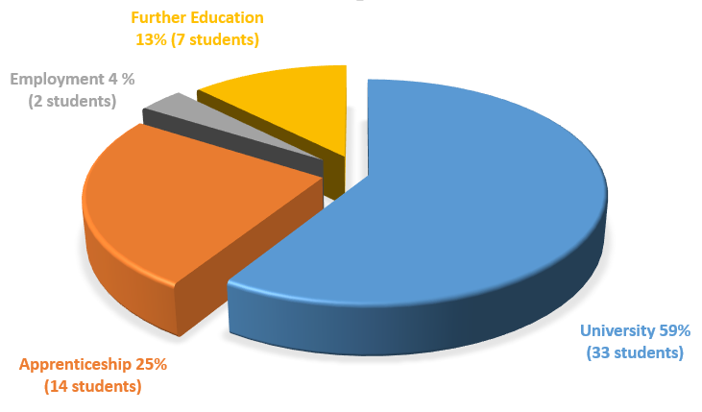

Working together to develop the skills for success in industry and university
Specialists in science, technology, engineering and maths
in partnership with industry and the University of Lincoln

Where are they now?
Year 13 student destinations

2017

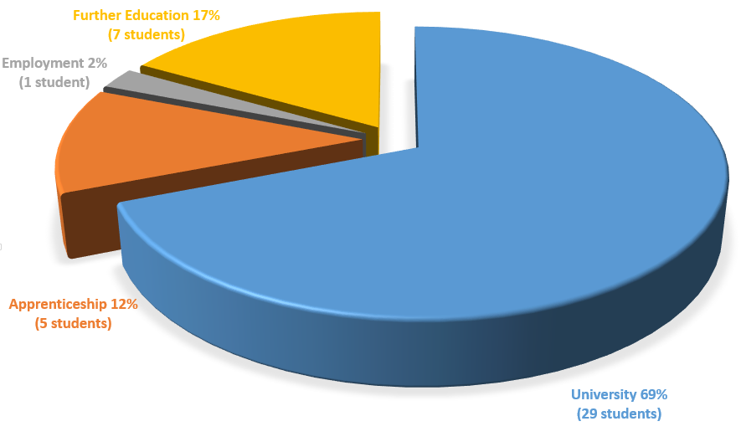

Working together to develop the skills for success in industry and university
Specialists in science, technology, engineering and maths
in partnership with industry and the University of Lincoln

Where are they now?
Year 13 student destinations

2018

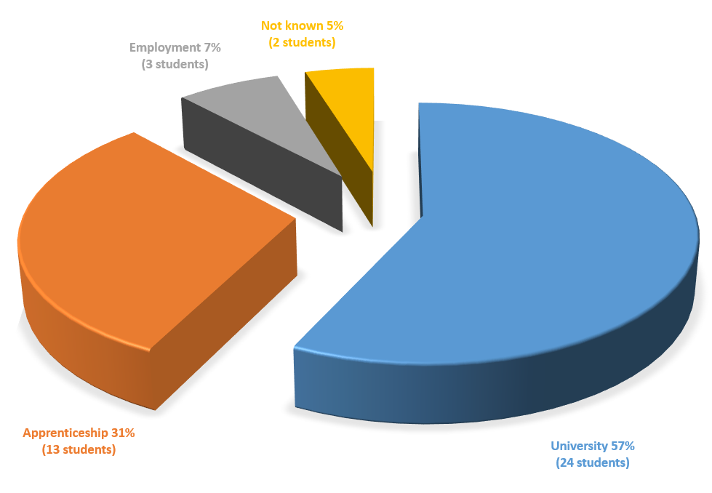

Working together to develop the skills for success in industry and university
Specialists in science, technology, engineering and maths
in partnership with industry and the University of Lincoln

Where are they now?
Year 13 student destinations

2019

Working together to develop the skills for success in industry and university
Specialists in science, technology, engineering and maths
in partnership with industry and the University of Lincoln

Where are they now?
Year 13 student destinations

2020

Working together to develop the skills for success in industry and university
Specialists in science, technology, engineering and maths
in partnership with industry and the University of Lincoln

